BAYES BUSINESS SCHOOL
MSc Banking and international finance
SMM150 – Data Analytics for Banking (2025)



A Comparative Analysis of Stock Performance Across Fossil Fuel and Renewable Firms
BIF Group 6:
Goyal Avisha | Avisha.Goyal@bayes.city.ac.uk
Rota Pietro | Pietro.Rota@bayes.city.ac.uk
Singh Ankit | Ankit.Singh@bayes.city.ac.uk
Surya Durgesh | Durgesh.Surya@bayes.city.ac.uk

Table of Contents

1. Introduction 1
2. Data Collection 1
3. Methodology 2
4. Data Analysis and Results 2
Descriptive Statistics 2
5. Visualisations 4
Price visualizations 4
6. Financial Metrics 7
Scatter plot analysis 7
ESG analysis 9
7. Conclusion 10
Data and Code 11
References 11

Introduction
This analysis examines the performance of major companies in the energy sector over the past year, especially looking at the renewable energy segment. This year has been characterised by heightened volatility and structural changes driven largely by geopolitical tensions, inflationary pressures, and shifts in global interest rates. Notably, traditional energy commodities, such as oil and natural gas, have underperformed compared to the previous three years. This reflects a confluence of softer demand and accelerating momentum behind the global transition toward cleaner energy sources.

Data Collection
All the Financial information was retrieved from the Bloomberg terminal using the BQL tool for easier date alignment, as these companies are listed on different stock exchanges, they observe different holidays. BQL also allows for currency conversion to British Pounds. The 10 companies that have been chosen are:
Table 1: Companies Table with Bloomberg Industry Classification Standard and Transition Readiness

They were selected to provide a general market overview rather than focusing on a specific jurisdiction. The primary objective is to analyse variations in their business models.
The selection includes varied business models: companies that are leading the climate transition like Ameresco, First Solar, and Vestas. Ameresco focuses on integrated clean energy solutions, including cogeneration and hydroelectric systems, First Solar dealing in solar panels, and Vestas creating offshore wind turbines. Then there are companies that are in the middle, such as Eni, Equinor, NextEra, and TotalEnergies, which still largely deal in hydrocarbons, but also articulated transition strategies and plans to at some point switch off their involvement in oil and gas even before the 2050 zero carbon target. Then there are companies like Shell, Chevron and Exxon that have no renewable aims and no intentions to develop them, have opted to focus on exploration, refinement, and sale of hydrocarbons.

Methodology
To analyse the companies in a comparable way, we took the daily returns:
$$Daily returns=\frac{P_{t}-P_{t-1}}{P_{t-1}}$$
Where $P_{t}$ is the price today, and $P_{t-1}$ what was the price yesterday.
Before this, we dropped all days where any market was closed, totalling 129 lost days for a total of 237 days where we have price data for all firms. Opting to reduce the number of days is the simplest way to make sure that all the data is aligned and there are no empty cells.

Data Analysis and Results

Descriptive Statistics
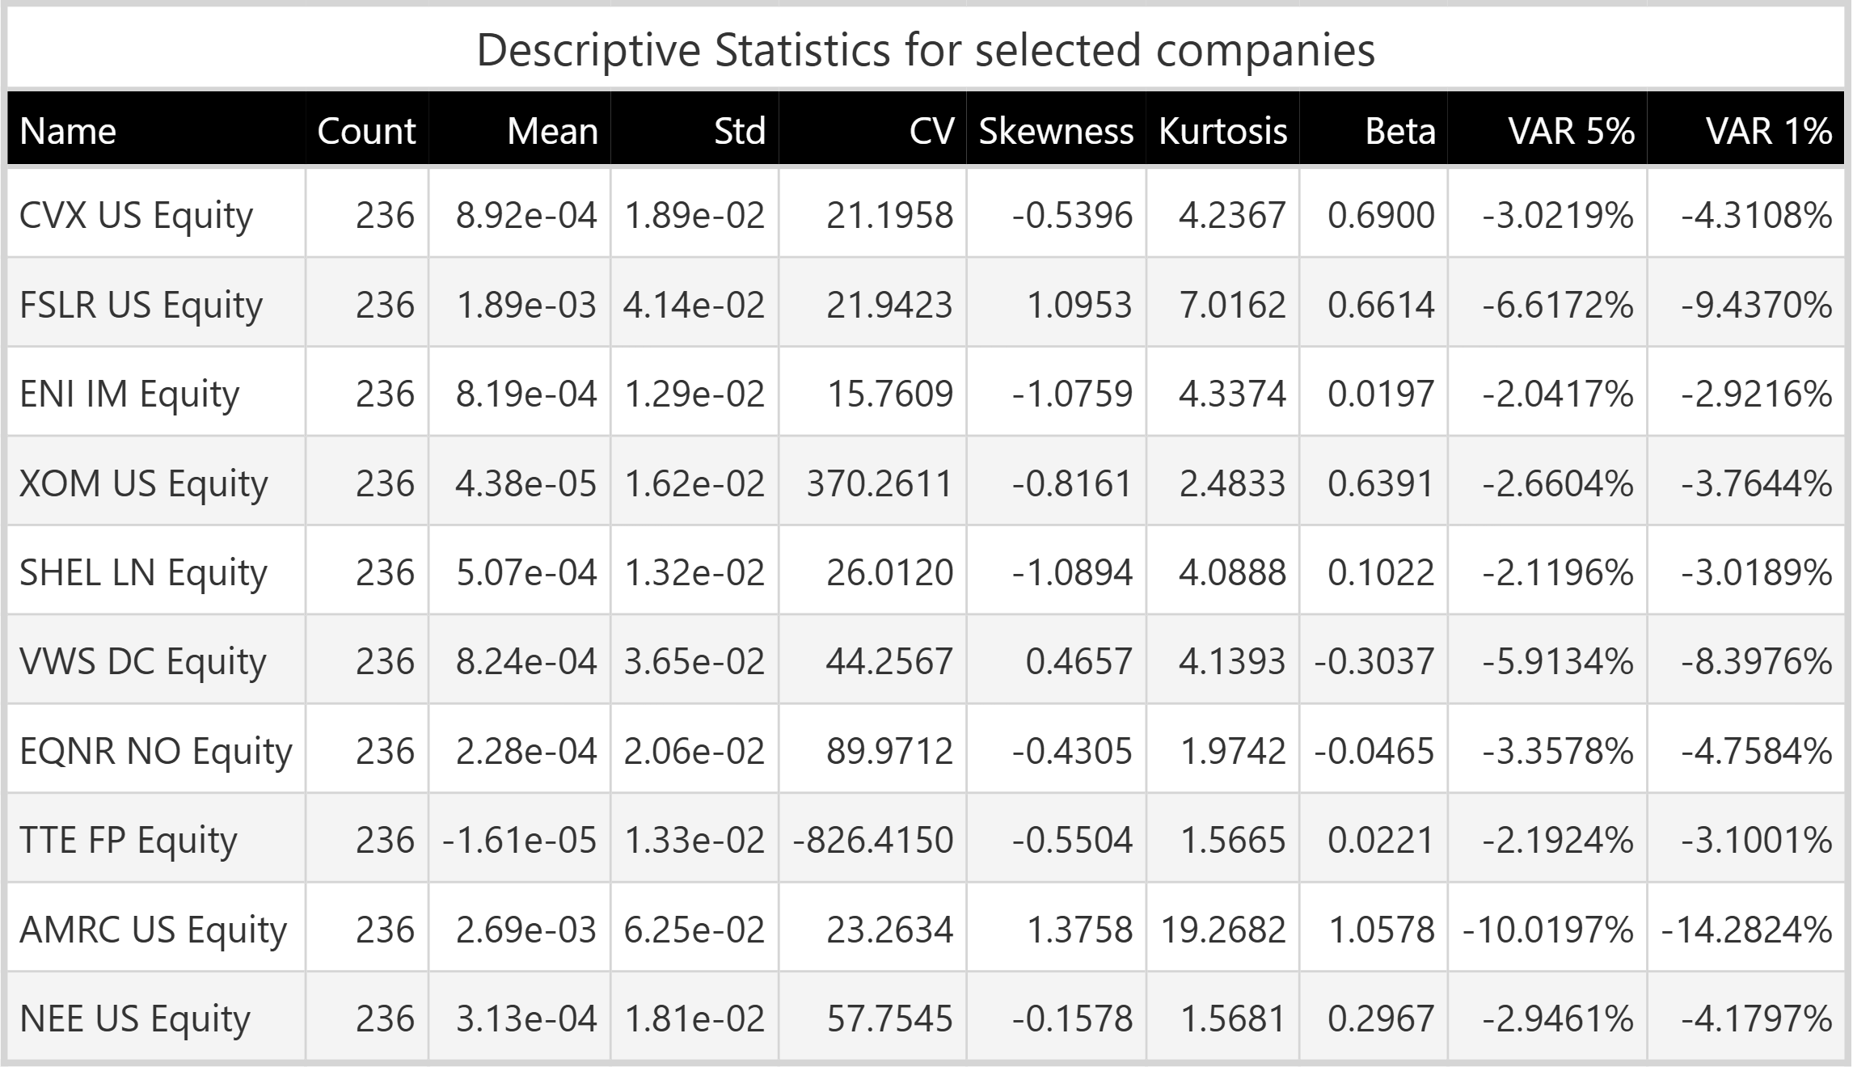
Table 2: Descriptive Statistics Table
This table showcases much of the descriptive statistics analysis. Overall, the returns were very low this year, with TotalEnergies going in the negative, renewables showing good daily returns, while the others maintained slim positive averages.
Standard deviation varied significantly, with the least risky stock, Eni, having a standard deviation of 1.29% and the most volatile, Ameresco, reaching 6.25%.
Coefficient of variation $CV=\frac{Standard deviation}{mean }$ serves as a measure of risk-per-unit-of-return. With low means, it becomes harder to interpret; only Eni had a CV under 20, which is the threshold for performing stocks. Ameresco had the strongest mean return coupled with the highest daily volatility, as it is common for the growth renewable plays often look like this. And of note, also Chevron had a lower mean, but also lower volatility.
Skewness is varied, ranging from negative, indicating a frequent number of small gains and a few extreme losses, to positive, indicating the potential for larger upside outliers. Renewables showed big upside tails, which are common for high-growth stocks, while all other companies show a negative skewness, meaning that they fall sharply on bad days, rise slowly on good days.
Kurtosis shows how much the tails contribute to the total distribution compared to the normal distribution, which signifies the likelihood of extreme outliers. Ameresco with the highest amount, showing a higher probability of extreme returns; the rest of the renewable stocks showed increased probability of extreme returns.
Beta ($β$) systematic risk is derived by using a reference index like the S&P 500, serving as a proxy for the overall economy. Ameresco was the only company with a defensive beta, indicating volatility on par with the index. Other companies showed a beta lower than 1, which indicates greater stability under changing market conditions. Vestas and Equinor had a negative beta, which represents a negative correlation with the index.
The 5% daily Gaussian VaR ranges from -2.04% Eni to -10% Ameresco. The 1% VaR confirms substantial downside risk in the volatile renewable energy stocks. However, these estimates are likely biased because the normality assumption is clearly violated for assets with such high kurtosis.

Visualisations

Price visualizations
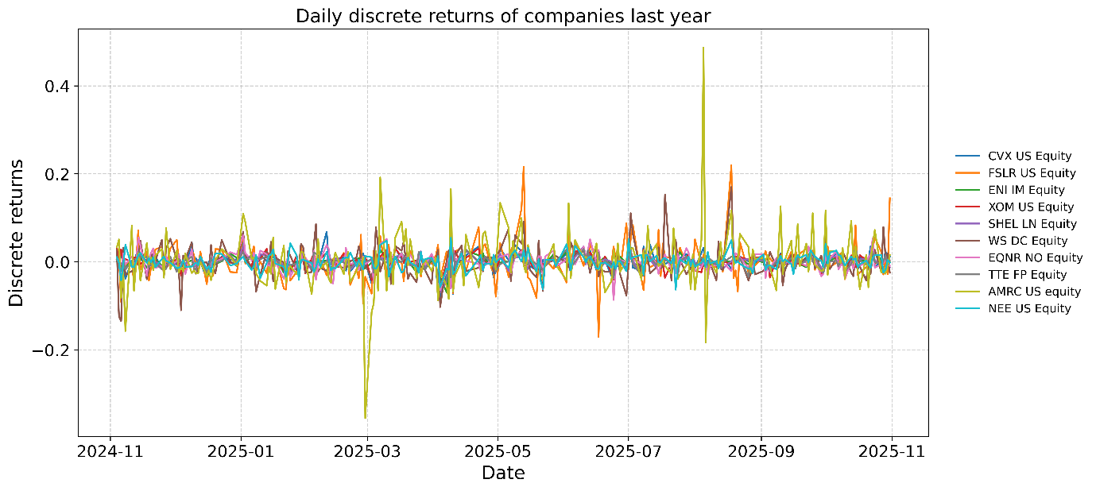
Figure 1: Daily Performance

This chart allows us to spot outlier days. Ameresco had a big drop in price following an earnings call but then recovered with positive earnings later in the year (Omotosho 2025). First solar, First Solar also experienced a price spike in August following a US government announcement regarding tax credit for clean energy projects (Bohen 2025).
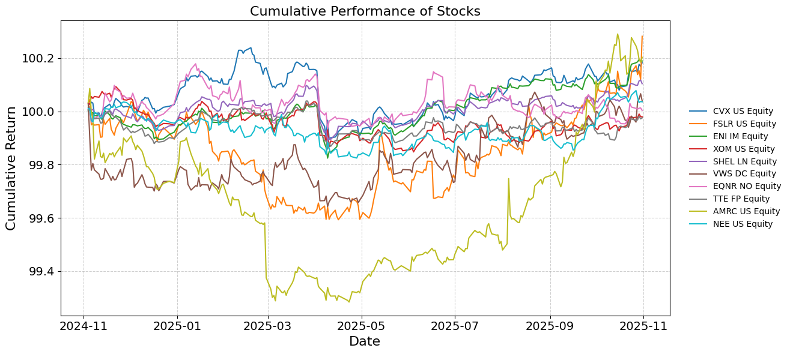
Figure 2: Cumulative Performance

This cumulative performance chart shows how all stocks performed starting from 100. Here, it is possible to see that stocks like, Chevron, Eni, Exxon, Shell, and TotalEnergies were hurt by the tariffs in April 2025. This was due to the implied increase in price for oil coming from overseas, which all these companies deal in, when tariffs raise fears of weaker global growth and reduced oil demand (International Energy Agency 2025). The renewables did not feel the same effects, proving their resilience to these kinds of geopolitical events.
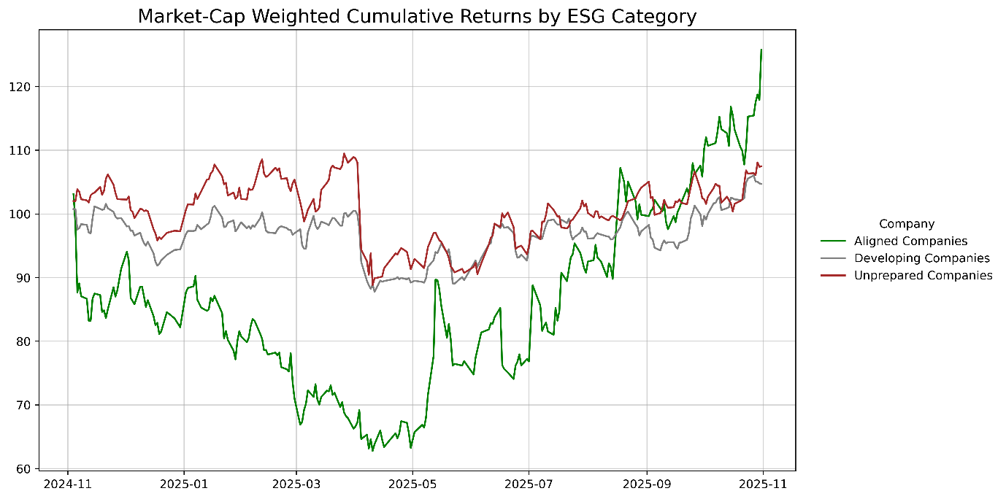
Fig 3: Cumulative Performance by Group

Just to get a final look at how these companies performed in the market this chart, this is a market cap weighted return chart where each daily return is multiplied by their market share among companies of the same climate readiness. The formula ends up being $w_{i,j}=\frac{m_{i,j}}{\sum_{k∈j}{m_{k,j}}}$, where $i$ is the individual asset and $j$ is the transition readiness and $k$ means all assets $i$ that belong to group $j$. With this, it is easy to see that although the climate-aligned companies collectively did not outperform the other two groups for most of the year, and in fact experienced a big drawdown for half of the year, they picked up pace and are now clear above the rest.
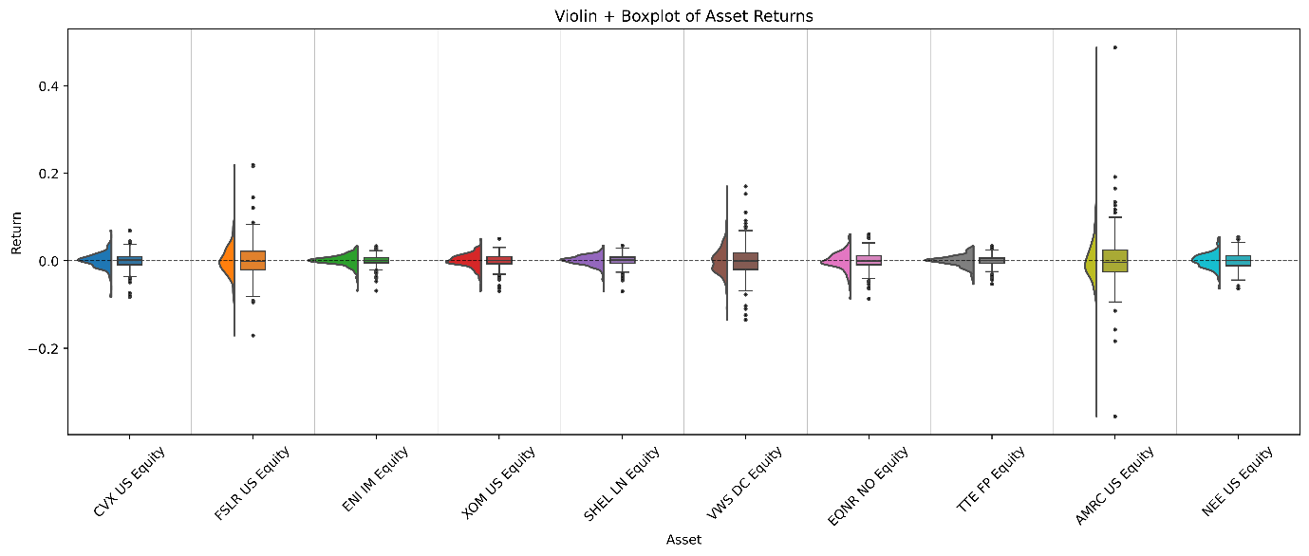Figure 3: Violin Boxplot of Returns

This violin and boxplots show the distribution of the companies’ returns and demonstrate that Firms such as First Solar, Vestas and Ameresco indicate a more spread distribution, showing higher risks, while TotalEnergies and Eni indicate more stable returns.
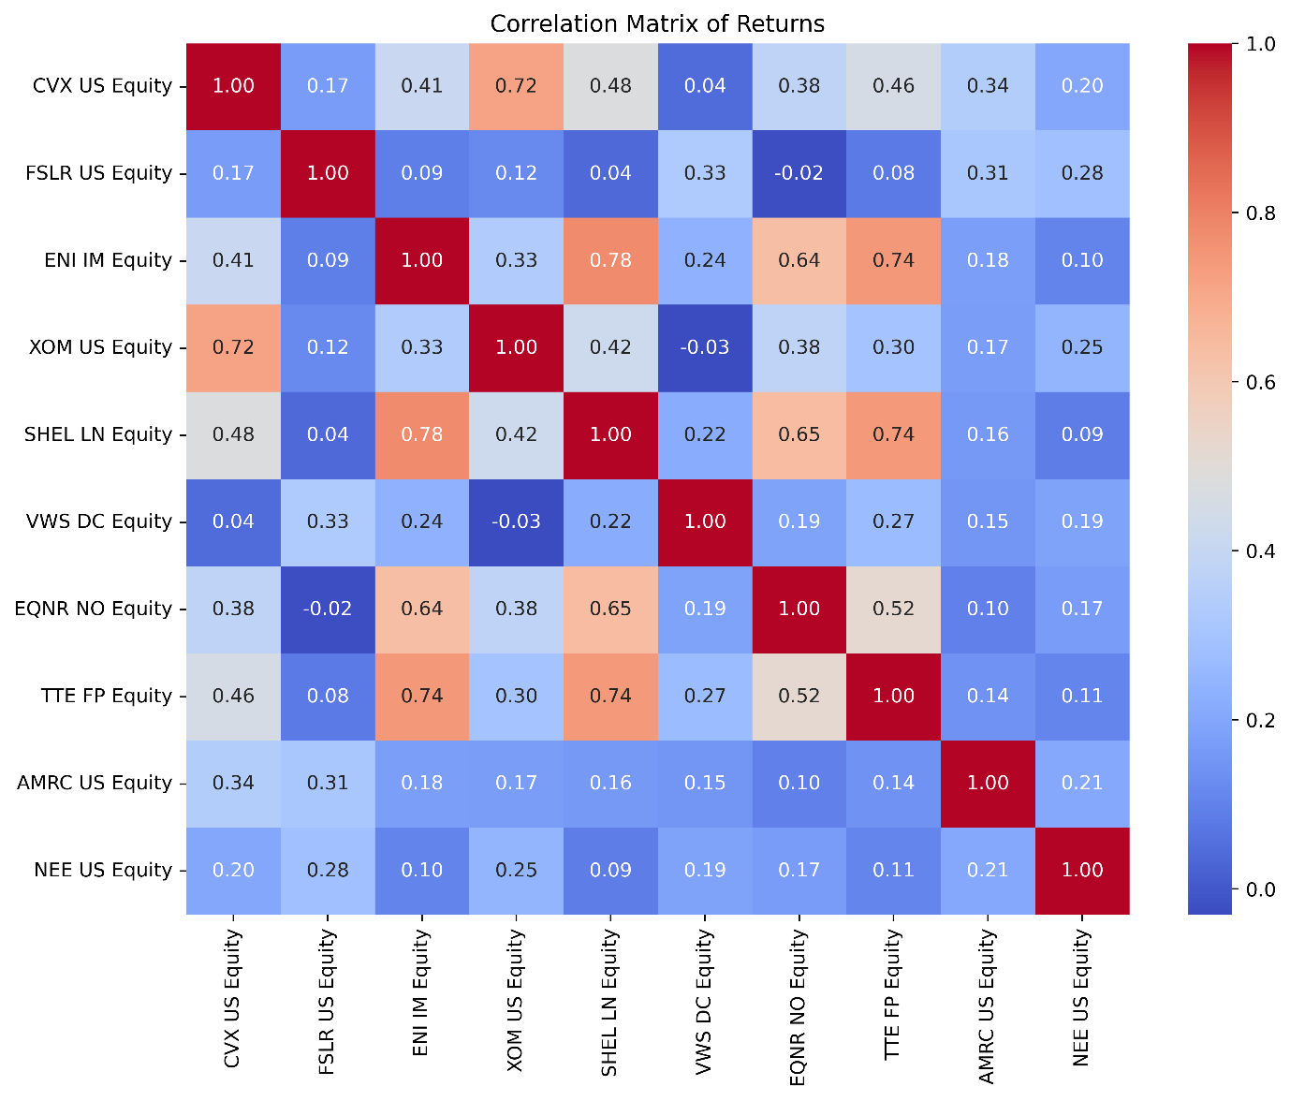
Figure 4: Correlation Matrix of returns

The correlation plot shows clearly the correlation that ENI, Exxon, Chevron, Shell, Equinor and TotalEnergies still have with each other, mainly due to their connection to the price of oil, while the rest do not really show strong correlations due to their businesses being overall diversified, so sector-specific changes did not impact them equally at the same time. Lastly, there is also no negative correlation to the oil giants; this might be a symptom of the overall difference in volatility experienced in the market.

Financial Metrics
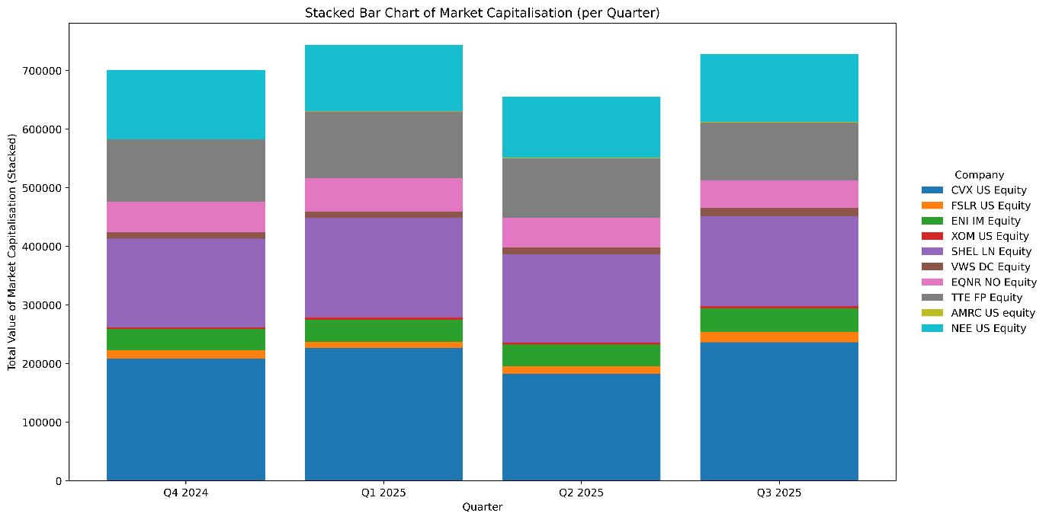
Figure 5: Market Capitalisation Stacked Bar chart

The stacked bar chart allows to see that the market overall did not expand that much over the last year; the overall market capitalisation of these firms increased only by 3.97% from 2024, mainly due to the hardships faced in the second quarter with tariffs and oil price pressure.

Scatter plot analysis
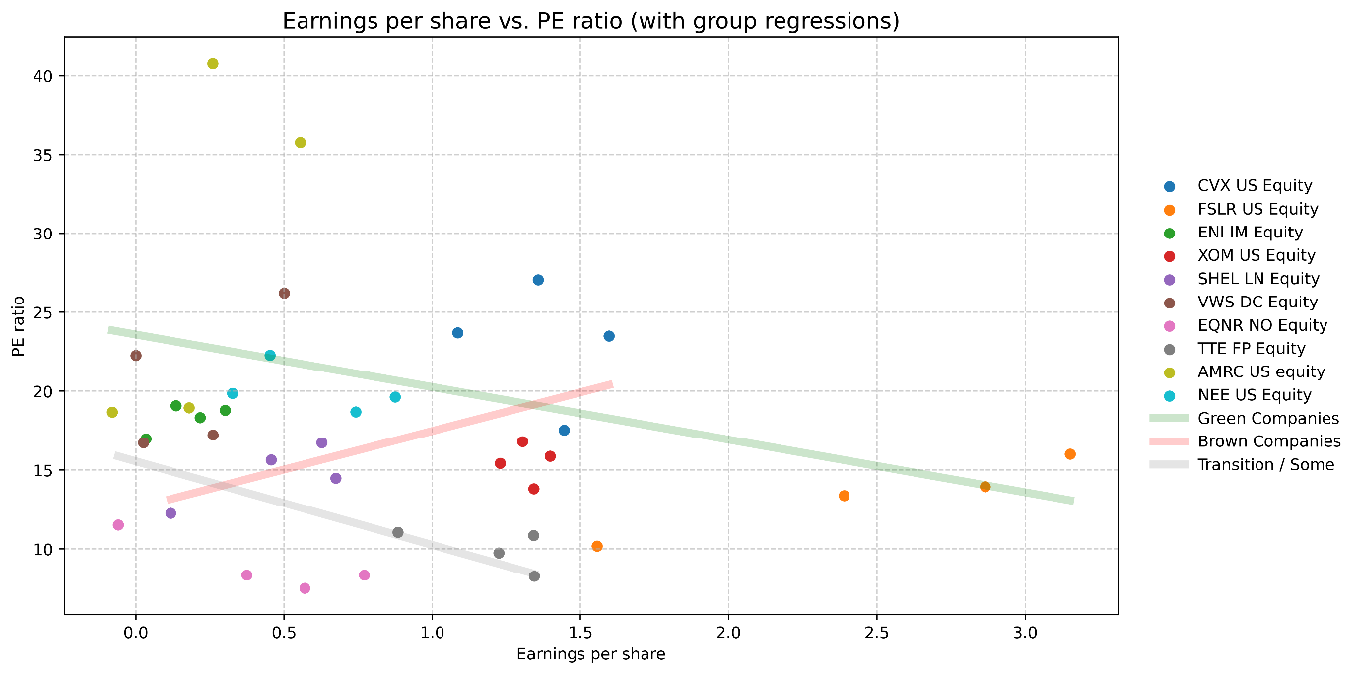
Figure 6: Earnings per Share vs. P/E Ratio Scatter Plot

The P/E and EPS are two ratios that are also connected in an inverse relation as .investors understand that this has been a difficult year for the sector and are betting on the results being better next year, increasing the P/E when the EPS is lower and vice versa, this is called the Molodovsky effect and although it is not present in all industries, in cyclical ones like the energy one it can be observed and used to explain such behaviour (Corporate Finance Institute 2024). This appears to be more present in the greener companies than in the oil companies, as they are seen as companies with more potential.
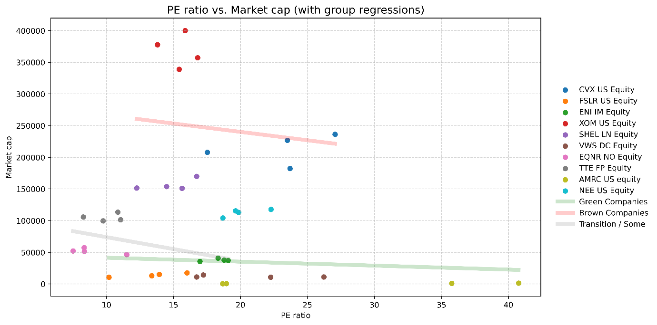
Figure 7: P/E ratio vs. Market Capitalisation Scatter Plot

The relationship between Earnings per Share (EPS) and Market Capitalization is presented showing weak investor sentiment towards larger companies, usually smaller companies have more hype and expectations behind them like Vestas and Ameresco, which are the 2 smallest firms by market capitalisation, but show higher P/E compared to giants like Exxon that for their massive market capitalisation of 4.2 billion trades at a valuation lower than expected for its size, alongside Chevron these more established companies are in the later growth and are thus being priced for reality not for dreams.

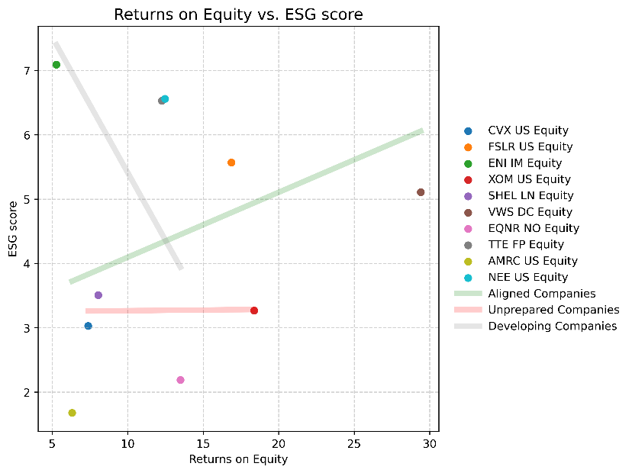
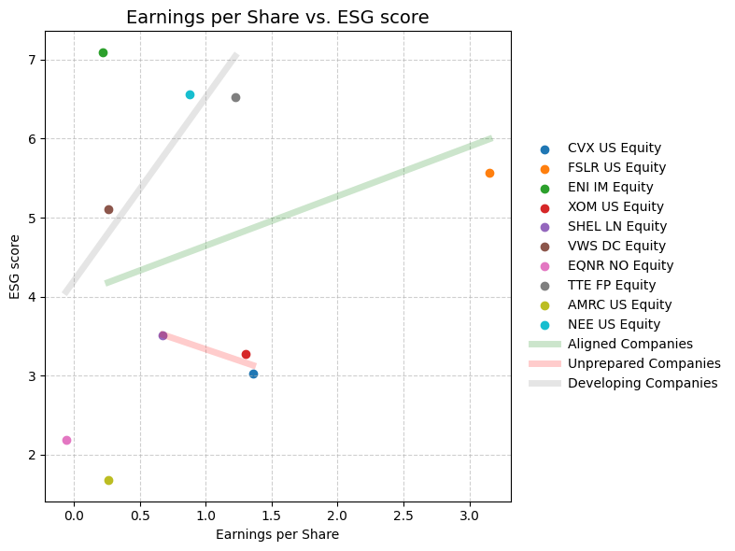
ESG analysis
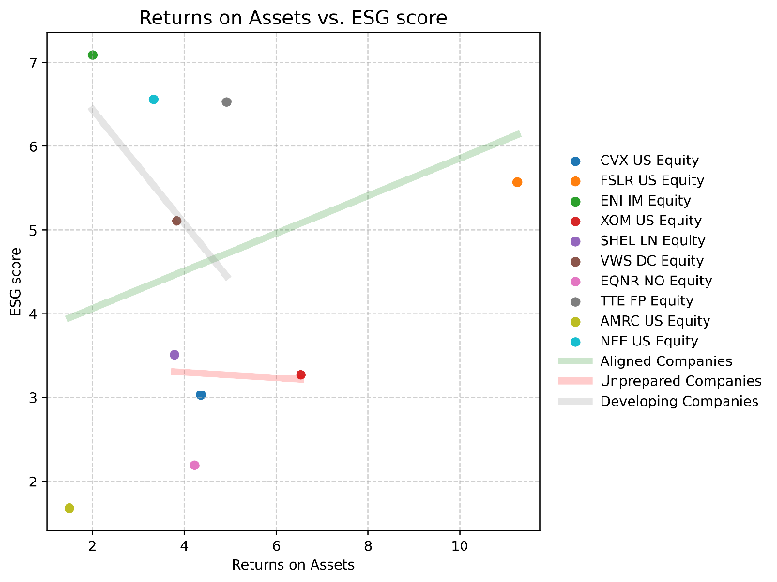
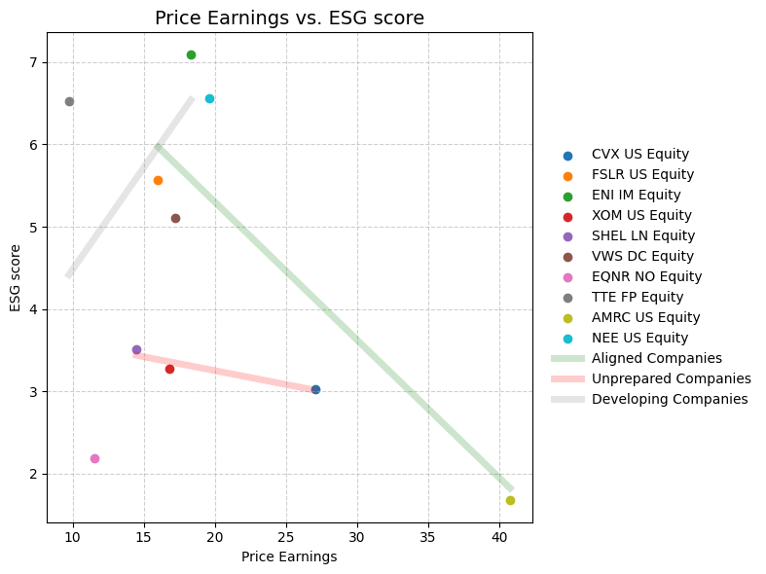
Figure 8: EPS and P/E ratio vs. ESG score
Figure 10: Profitability (ROA and ROE) vs. ESG score Scatter Plot

When looking at the ESG score, the story is clear: the market still wants companies to move towards greener investments. Across our sample, clean companies are consistently associated with stronger financial performance. While ROA highlights the operational efficiency of the asset-heavy oil majors, the ROE is crucial for understanding the renewable firms, which rely heavily on equity financing for growth. Interestingly, firms with better sustainability profiles tended to outperform in both metrics, suggesting that the 'green premium' is supported by genuine operational efficiency and lower risk premia. This relationship extends to the EPS as well: companies with stronger ESG credentials typically command larger revenues over the last year. Overall, the evidence points to a positive correlation between ESG quality and both profitability and market perception in all but the P/E ratio, as higher ESG scores can signal higher costs and lower short-term profitability, which can pressure P/E ratios.
Meanwhile, Oil companies show no correlation to any ESG variables, implying that investors and other market participants do not value them based on ESG.

Conclusion
This study provides empirical evidence of a structural divergence within the energy sector, driven by the ongoing global energy transition. The analysis of financial metrics and descriptive statistics confirms that the sector is split between established incumbents acting as defensive anchors and volatile disruptors representing speculative growth. These companies have stood the test of a rather difficult year and have also shown resilience, especially when it comes to the looming threat of tariffs and different kinds of market pressures that have impacted oil and gas in the last year, whether it is inflationary, geopolitical tensions, including armed conflicts and trade restrictions.
The renewable segment exhibits higher probability of extreme events compared to the integrated oil majors. This volatility is further supported by Beta coefficients; firms such as Ameresco exceed market risk, while integrated Oil companies like Shell and Chevron act as defensive assets.
The scatter plot analysis of fundamentals reveals a market preference for "growth potential" over "current value", with investors that appear willing to assign higher valuation multiples to firms despite lower or volatile earnings, banking on future growth.
Contrary to standard liquidity premiums, the analysis suggests that larger capitalised firms (i.e., Exxon, Shell) trade at lower P/E multiples. This indicates that the market prices these giants for "reality", discounting their mature growth profiles, while actively pricing smaller renewables for "dreams," with a hype premium.
Finally, the ESG analysis highlights a maturing market rationality. There is a consistent positive correlation between ESG scores and profitability metrics. This suggests that sustainable practices are no longer just a compliance cost but are associated with operational efficiency. However, the lower P/E ratios often found in the highest ESG scorers imply that investors remain cautious about the capital intensity required for the transition, especially in the short term.
1929 words

Data and Code
The data and accompanying code used in this analysis can be accessed at the following repository:
https://github.com/Pietro-Rota/Data-Analytics-for-Banking

References
Bohen, Tim. 2025. “FSLR Stock Surge: What’s Next?” Stockstotrade, August 15, 2025. https://stockstotrade.com/news/first-solar-inc-fslr-news-2025_08_15-2
Corporate Finance Institute. 2024. “Molodovsky Effect.” Corporate Finance Institute, September 10, 2024. https://corporatefinanceinstitute.com/resources/career-map/sell-side/capital-markets/molodovsky-effect
International Energy Agency. 2025. “Oil Market Report for April 2025,” April 2025. https://www.iea.org/reports/oil-market-report-april-2025.
Omotosho, Kayode. 2025. “Why Ameresco (AMRC) Stock Is Trading Lower Today.” Yahoo Finance, February 28, 2025. https://finance.yahoo.com/news/why-ameresco-amrc-stock-trading-192128114.html.

